**Team 6 – Machine Learning Model for Brewery Investment Decision**

Context: As the data analytics department for a hedge fund, our responsibility is to provide decision making tools to our executives for investment decisions.

Based on our data gathering and modeling, we can answer the following questions:

1. Is a brewery candidate county over or under saturated with breweries?
2. Is an under saturated county a good candidate for investing in the construction of a high-end brewery? (Based on Top-Tier brewery county demographics)

Models:

* County Brewery Saturation Level
* Inputs:
* Median Income (By County)
* % College Ed (By County)
* Population
* (Explore other demographics) – use coefficients to optimize fit.
* # of Breweries (by type if needed)
* Output:
* Is a county oversaturated or undersaturated?
* Would the county’s demographics support a top tier brewery investment?
* Inputs:
* Median Income (By County)
* % College Ed (By County)
* Population
* Top 50 list (Largest and Best)
* Output:
* Would the county’s demographics support a top tier brewery investment?

Two Required Technologies we are going to use:

* We will use Tableau, and we have already used several technologies during Project 2

How will we host the project? (Heroku, github pages, or something else)

* Per Dan’s guidance, we will likely use Tableau to host this project.

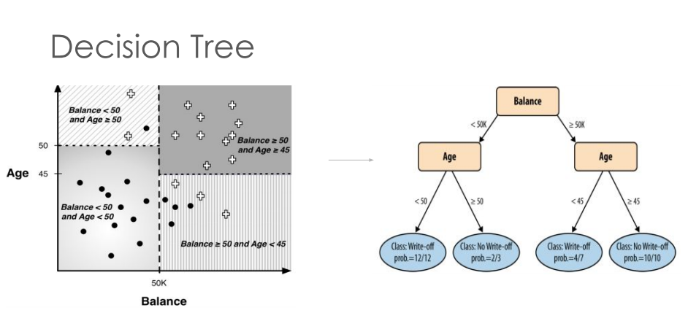

To Dos:

* Confirm if we can expand our list of breweries (Rob)
* Add population of county to FinalDemographicsRg excel file (Phil)
* Investigate Census Data (all) bring county data for 1-3 demographic metric for Tuesday. (All)
* Brush up on Machine Learning, Lesson 21
* Create a GitHub Repo (Adam)